SQL Exercise 9

**Purpose:** Nine SQL exercises will be released throughout the quarter. These assignments will help you connect and manipulate a database through Python. Python-to-SQL is a parallel strand of knowledge that you would gain in this class.

**Reference:** 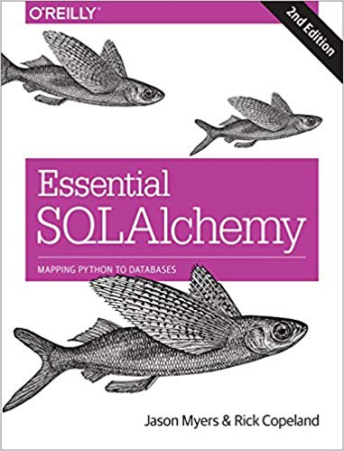

**Code:** Time to practice! Try the code below and get it to work. The code is pre-tested and should run “as is.” Verify what you type if an error persists. Press “Run” to every time you completed a jupyter cell. Because you already have content knowledge of what is a database, most of the code are self-explanatory.

***Instructions:*** *Start a new Python project folder … do not reuse the previous workspace … As with any keyboard-driven console-like environment, developing muscle -memory for the common commands is also part of the learning curve.*

**Viewing database:** To view the database created by Python, you may use a SQL Lite viewer. This tool is posted inside Week #2 in Canvas; look for DB.Browser.for.SQLite-3.10.1-win64

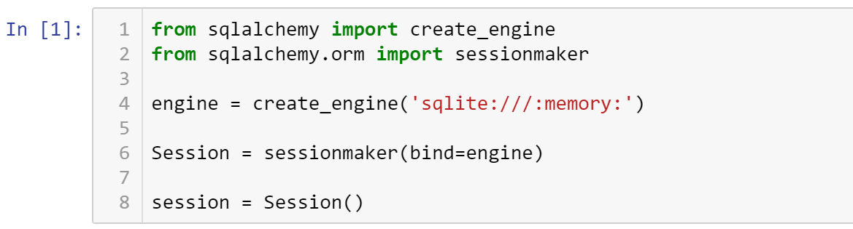

Some of these codes may look repeated, but they are here for a different purpose.



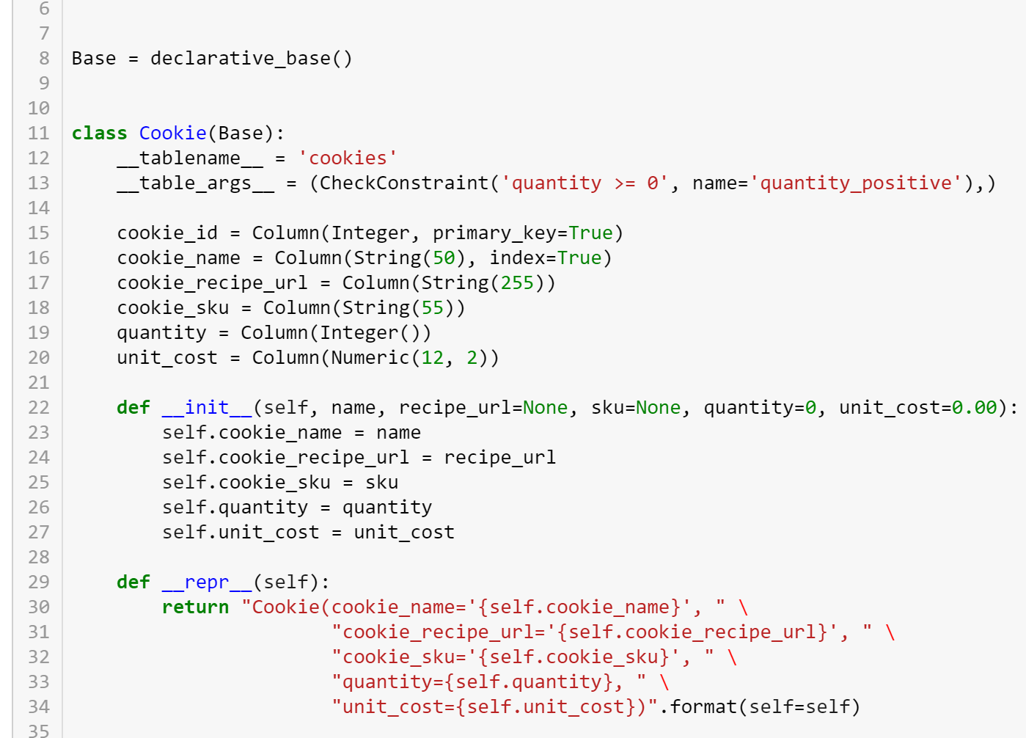

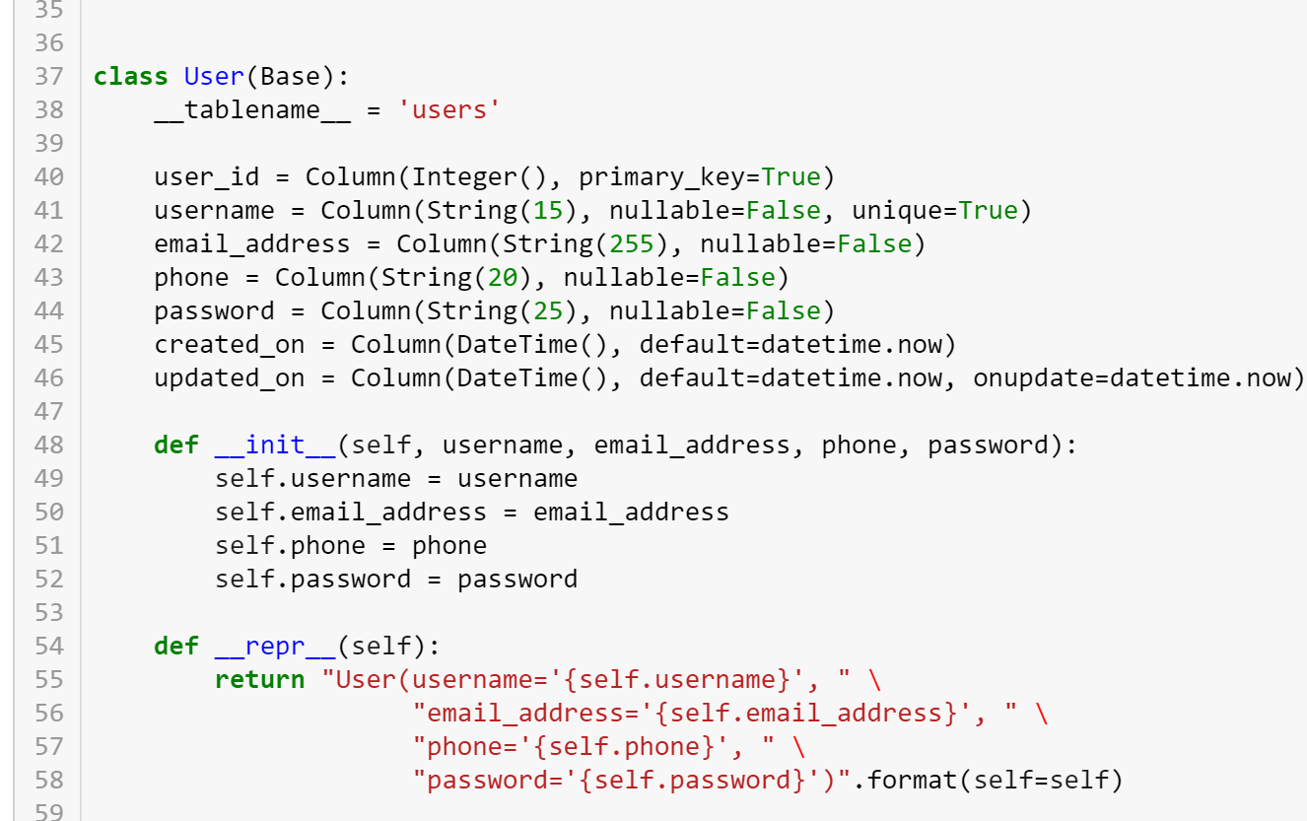

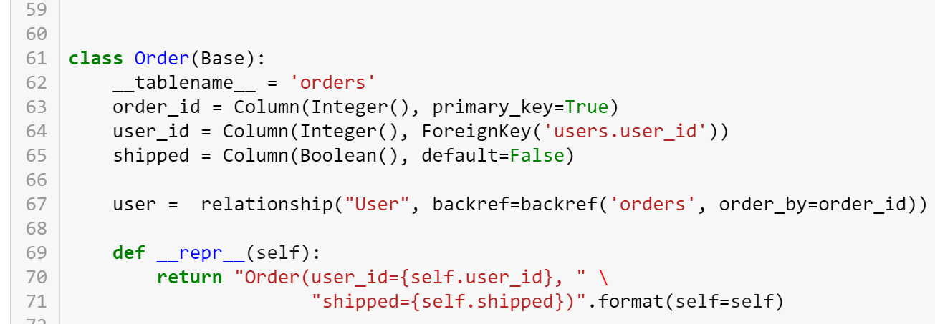

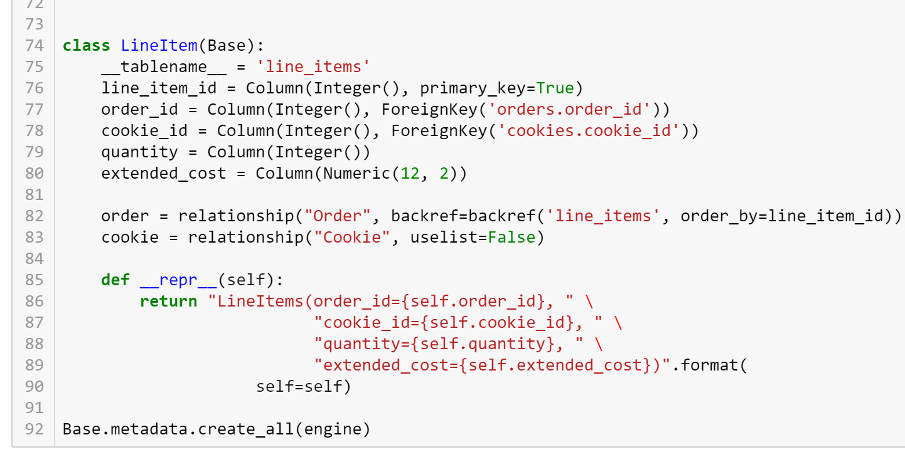

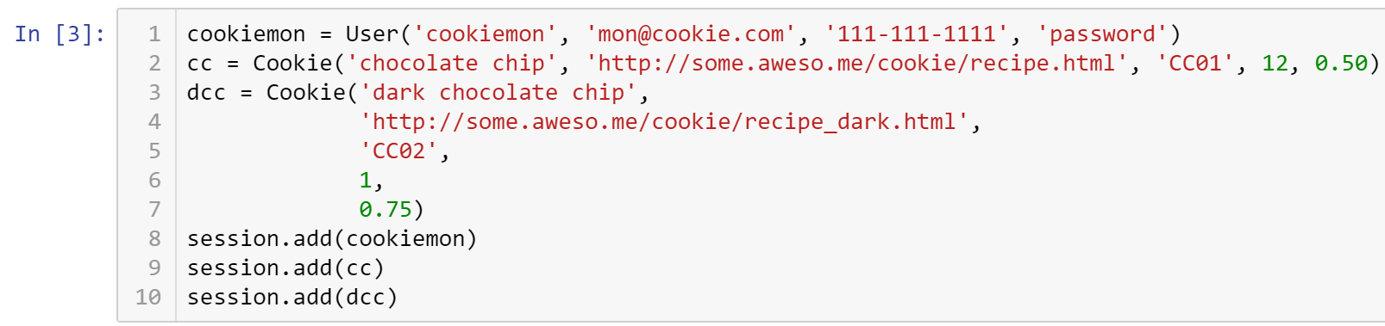

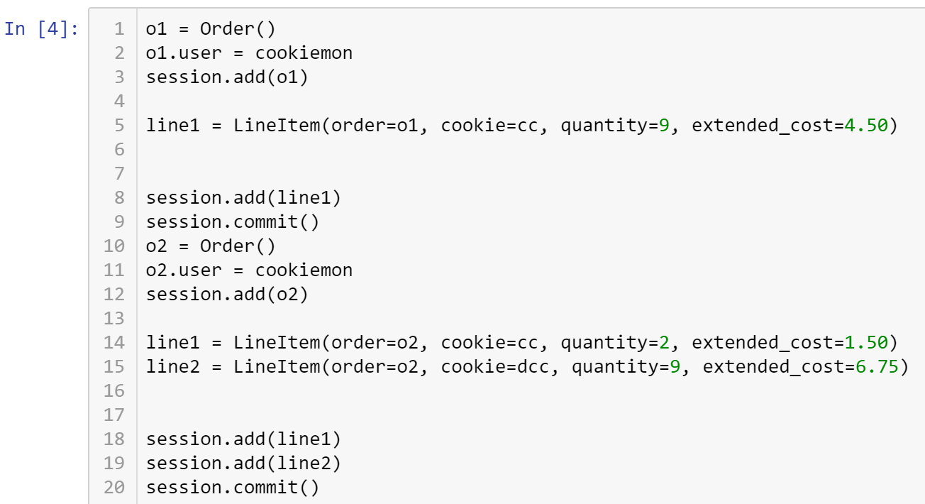

/Users/jasomyer/.virtualenvs/sa-book-dev/lib/python2.7/site-packages/sqlalchemy/sql/type_api.py:322: SAWarning: Dialect sqlite+pysqlite does *not* support Decimal objects natively, and SQLAlchemy must convert from floating point - rounding errors and other issues may occur. Please consider storing Decimal numbers as strings or integers on this platform for lossless storage.

d[coltype] = rp = d['impl'].result_processor(dialect, coltype)

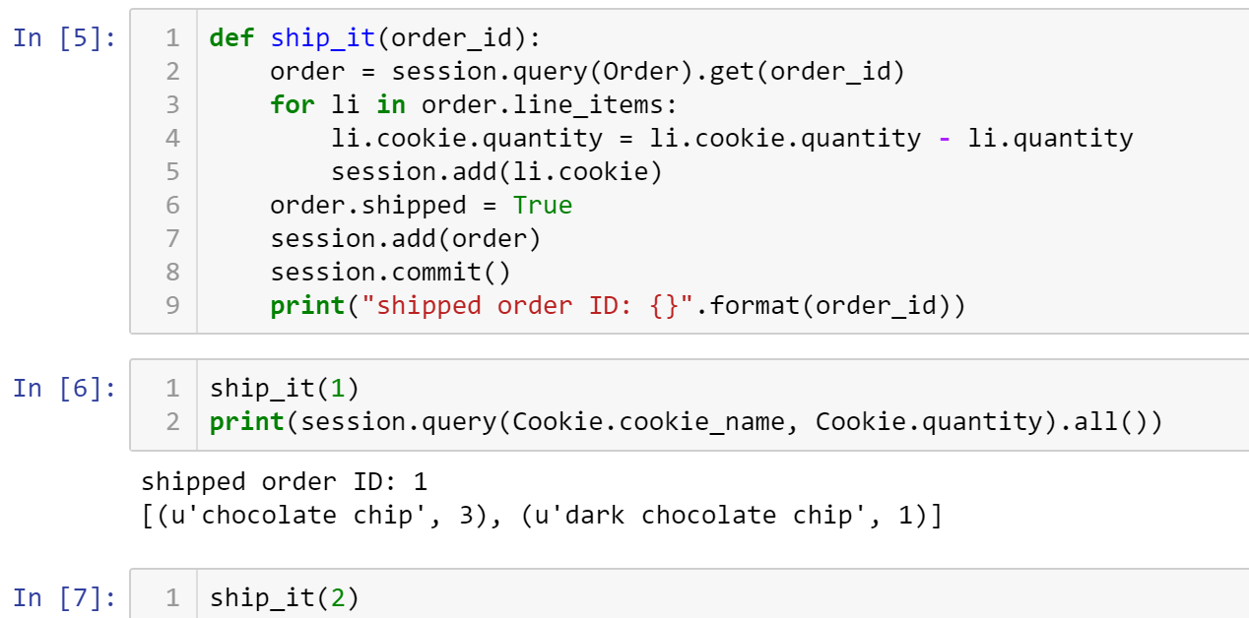

You may get an Integrity error.



InvalidRequestError: This Session's transaction has been rolled back due to a previous exception during flush. To begin a new transaction with this Session, first issue Session.rollback(). Original exception was: (IntegrityError) CHECK constraint failed: quantity_positive u'UPDATE cookies SET quantity=? WHERE cookies.cookie_id = ?' (-8, 2)

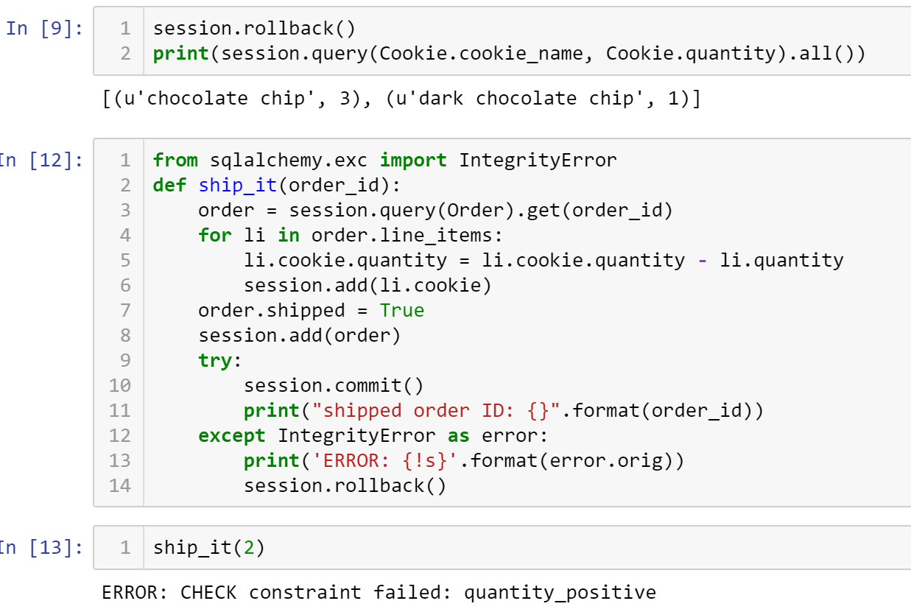

* **Critical Thinking Section:** In your own words, explain in a paragraph (5 sentences or more) describing what is a session or transaction rollback.
* Place your answer here below:

|  |
| --- |
|  |

* Place your name at the bottom of your code, download your Python program in html format, and submit your work in Canvas.

**Viewing database:** To view the database created by Python, you may use a SQL Lite viewer. This tool is posted inside Week #2 in Canvas; look for DB.Browser.for.SQLite-3.10.1-win64

**Important:** All submissions should be separate from other exercises and quests. Please do not lump all your answers into one document and re-using that same workspace to gain multiple points. Thanks.